**Lab Test – 2 (Week-13)**

**COMP 3123 – Full Stack Development I**

**Total Points (06%)**

**Submission Deadline: Thursday, 30th Nov 2023 08:00 PM**

**Note:**

1. Create git repository name **studentid_comp3123_ labtest2**
2. **You code will be evaluated against any plagiarism**
3. **You can use your own preferred free weather API OR Can use any other free API like food, movies, auto mobiles, products, etc.**
4. **Make use of React feature like props, state, hooks, life cycle methods, function/class component and axios.**
5. Create free account if you don’t have one on <https://openweathermap.org/> to get **API key**
6. Use **axios** or **fetch** to access REST API
7. Please read the response fields detail from <https://openweathermap.org/forecast16>

<https://openweathermap.org/weather-conditions>

1. Use following end point to get weather data

*http://api.openweathermap.org/data/2.5/weather?q=Toronto&appid=****{{APIkey}}***

**Assignment Details**

* **Refer attached JSON file for response**

1. Create a ReactJS application having name **studentId_comp3123_labtest2** and **connect to GitHub repository (10 Point)**
2. Used icons/images/theme/fonts for weather condition. Refer icons from <https://openweathermap.org/weather-conditions> **(20 Points)**

Sample: <http://openweathermap.org/img/wn/10d@2x.png>

1. Based on the response from API **think of your own UI/UX** and display all the information. **(30 points)**
2. Add Search or any dynamic content change feature. (**(10 points)**
3. Display relevant required information from response. Can use any free template for design. **(20 Point)**
4. Create [**ReadMe.md**](https://www.markdownguide.org/cheat-sheet/) file on GitHub to document and show your screens output with descriptions. **(10 Point)**

**Reference Design**

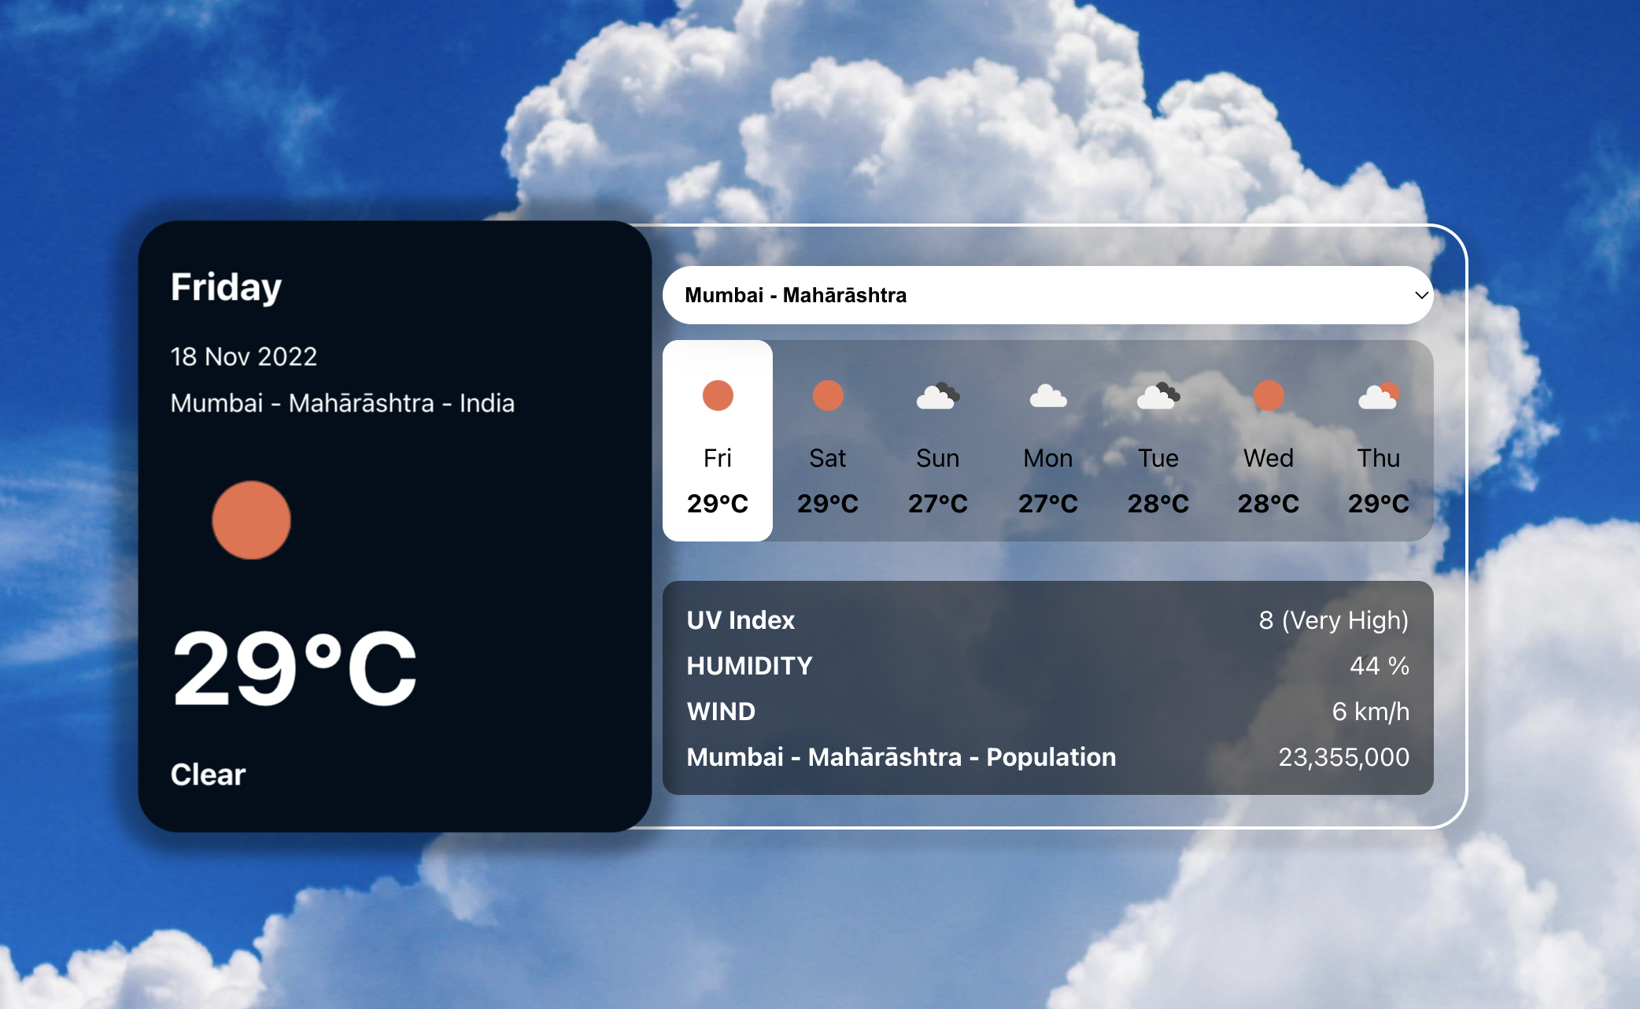

**Postman**

**Submission**

1. Create the ZIP file having all your source code**.** Remove **node_modules** folder before zip.
2. Put the screenshots of all your outputs and GitHub link in single docx.
3. Put the screenshots of POST man response.
4. Upload the ZIP file having name **studentId_comp3123_labtest2** and **GitHub project link** on the blackboard on or before the deadline. *NO email will be accepted for any late submission of GitHub/screenshots links and source code.*
5. **ZERO** % will be awarded for any late submission.

**Communication**

Please contact on [pritesh.patel2@georgebrown.ca](mailto:pritesh.patel2@georgebrown.ca) or SLACK channel for any question or query.

**References**

<https://www.digitalocean.com/community/tutorials/react-axios-react>

<https://openweathermap.org/forecast16>

<https://designrevision.com/react-axios/>

<https://www.smashingmagazine.com/2020/06/rest-api-react-fetch-axios/>